Course: Design Analysis And Algorithm Name: Pooja S
Code: CSA0606 Regno:192524211
Date:07.10.2026 Slot: B
Session-3 Lab Programs

10. def findPaths(m, n, N, i, j):
dp = [[0] * n for _ in range(m)]
dp[i][j] = 1
ans = 0
for step in range(N):
new_dp = [[0] * n for _ in range(m)]
for r in range(m):
for c in range(n):
if dp[r][c] > 0:
if r == 0:
ans += dp[r][c]
else:
new_dp[r - 1][c] += dp[r][c]
if r == m - 1:
ans += dp[r][c]
else:
new_dp[r + 1][c] += dp[r][c]
if c == 0:
ans += dp[r][c]
else:
new_dp[r][c - 1] += dp[r][c]
if c == n - 1:
ans += dp[r][c]
else:
new_dp[r][c + 1] += dp[r][c]
dp = new_dp
return ans
m = int(input("Enter m: "))
n = int(input("Enter n: "))
N = int(input("Enter N: "))
i = int(input("Enter starting row i: "))
j = int(input("Enter starting column j: "))
print("Number of ways:", findPaths(m, n, N, i, j))
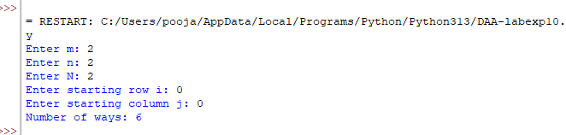

11. def rob_linear(nums):
prev = 0
curr = 0
for money in nums:
new = max(curr, prev + money)
prev = curr
curr = new
return curr
def rob(nums):
n = len(nums)
if n == 1:
return nums[0]
case1 = rob_linear(nums[:-1])
case2 = rob_linear(nums[1:])
return max(case1, case2)
n = int(input("Enter number of houses: "))
nums = []
for i in range(n):
nums.append(int(input("Enter money in house: ")))
print("Maximum money:", rob(nums))
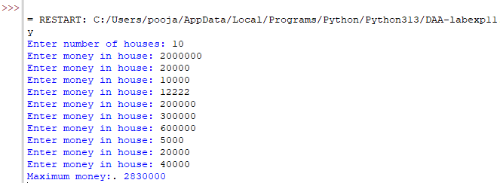

12. n = int(input("Enter number of steps: "))
if n == 1:
ways = 1
elif n == 2:
ways = 2
else:
a = 1
b = 2
for i in range(3, n + 1):
c = a + b
a = b
b = c
ways = b
print("Number of ways:", ways)
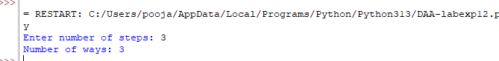

13. def uniquePaths(m, n):
dp = [[1] * n for _ in range(m)]
for i in range(1, m):
for j in range(1, n):
dp[i][j] = dp[i - 1][j] + dp[i][j - 1]
return dp[m - 1][n - 1]
m = int(input("Enter number of rows: "))
n = int(input("Enter number of columns: "))
print("Number of unique paths:", uniquePaths(m, n))
